**PROG8080**

**PROGRAMMING: DATABASE MANAGEMENT**

**Assignment: 3**

**Name: Shravani Gandla**

**Student ID: 8697289**

1. Query full names and birthdates and sort them by their birthdate.

Query:

SELECT lastName,firstName,birthdate FROM Person ORDER BY birthdate;

Output:

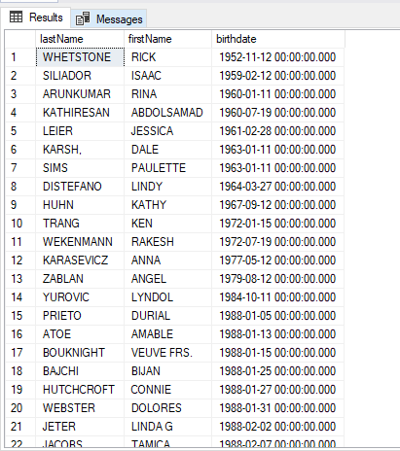

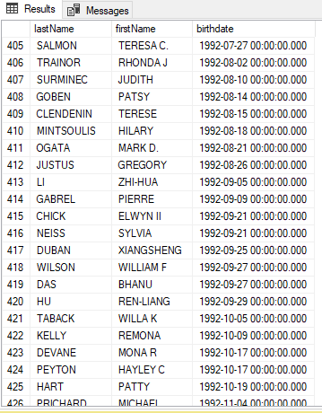

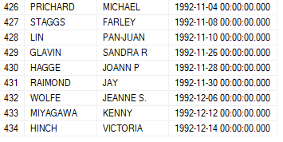

1. We need to get the postal code of the person with number: 7572381

Query:

SELECT lastName,firstName,postalCode FROM Person WHERE postalCode = '7572381';

Output:

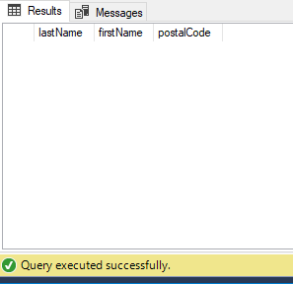

1. How many students have NULL balance?

Query:

SELECT balance FROM Student WHERE balance IS NULL;

OUTPUT:

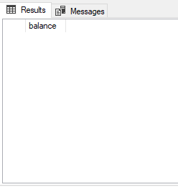

1. Write a query to show number,local city,and balance of the students with negative amount in their balance.

Query:

SELECT number,localCity,balance FROM Student WHERE balance<0;

OUTPUT:

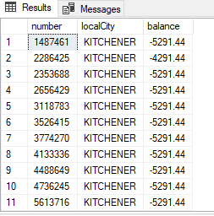

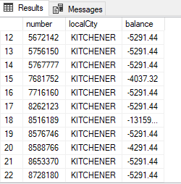



1. Write a query to show number, local city and balances of the students with negative amount in their balance and sort them by their balances from highest value to lowest.

Query:

SELECT number,localCity,balance FROM Student WHERE balance<0 ORDER BY balance DESC;

OUTPUT:

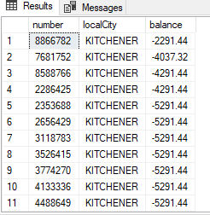

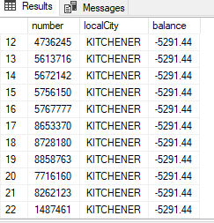



1. Write a query to show number, local city, and balance of the students. with negative amount in their balance and sort them by their balances from highest value to the lowest. Change the Title to “Student ID”, City, and Dept.

Query:

SELECT number AS StudentID,localCity AS City,balance AS Dept FROM Student WHERE balance<0 ORDER BY balance DESC;

OUTPUT:

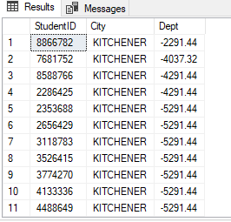

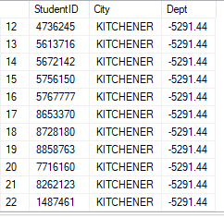



1. Write a query to show the first name, last name, alternate phone number, and country code of the persons who have a Null value in their alternate phone numbers and their country code is not ‘CAN’.

Query:

SELECT firstName,lastName,countryCode,alternatePhone FROM Person WHERE alternatePhone IS NULL AND countryCode<>'CAN';

OUTPUT:

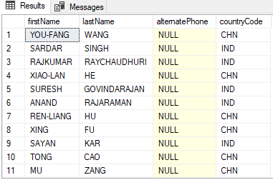

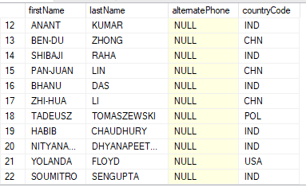

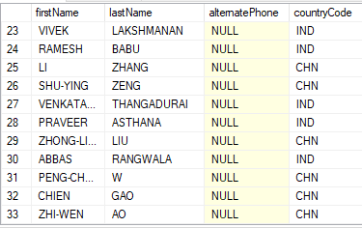

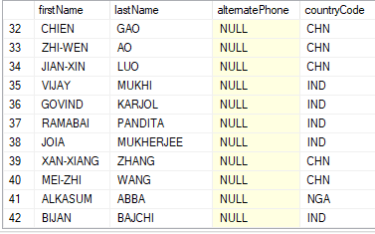

1. Write a query to show the first name, last name, alternate phone number, and country code of the persons who have a Null value in their alternate phone numbers and their country code is not ‘USA’ or ‘CHN’.

Query:

SELECT firstName,lastName,alternatePhone,countryCode FROM Person WHERE alternatePhone IS NULL AND countryCode<> 'USA' AND countryCode<>'CHN’;

OUTPUT:

